# Experiment-2.3

## Student Name: Nabha Varshney UID: 20BCS4995

**Branch: CSE Section/Group: 20BCS-DM-704 (A)**

## Semester: 6th Date of Performance:12th Apr 2023 Subject Name: Competitive Coding II Subject Code: 20CSP- 351

**Aim** – To demonstrate the concept of divide and conquer.

## Objective-

* The objective is to build problem solving capability and to learn the basic concepts of data structures.
* The implementation of Count and say which shows and brushes up the concept of divide and conquer and can be solved through various approaches.
* The implementation of water and jug problem in C++.

## Count and Say

<https://leetcode.com/problems/count-and-say/description/>

**Code –**

class Solution {

public:

    string countAndSay(int n) {

        if(n == 1) {

            string str = "";

            str += '1';

            return str;

        }

        string ans = countAndSay(n-1);

        string str = "";

        for(int i=0; i<ans.size(); i++) {

            int count = 1;

            while(i != ans.size()-1 && ans[i] == ans[i+1]) {

                count++;

                i++;

            }

            str += (count + '0');

            str += ans[i];

        }

        return str;

    }

};

## Output -

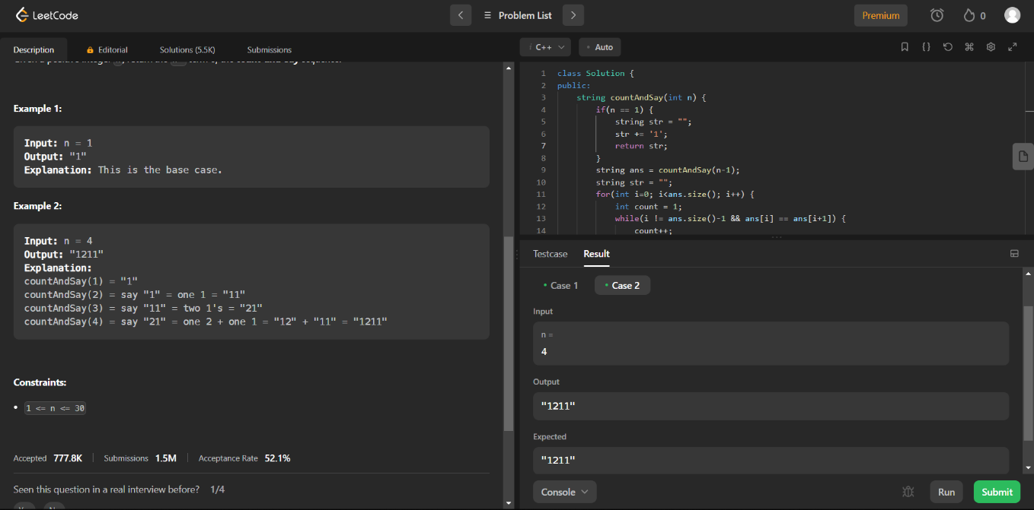

1. **Water and Jug Problem**

<https://leetcode.com/problems/water-and-jug-problem/>

**Code -**

class Solution {

public:

    bool canMeasureWater(int jug1Capacity, int jug2Capacity, int targetCapacity) {

        if(targetCapacity == 0)

        {

            return true;

        }

        if(targetCapacity > jug1Capacity + jug2Capacity)

        {

            return false;

        }

        else

        {

            int g = gcd(jug1Capacity,jug2Capacity);

            return targetCapacity % g == 0;

        }

    }

};

## Output –

